FINAL EXAMINATION
TIME ALLOWED: 90’
Subject: Linear Algebra. No books allowed.

1/ Find the matrix such that 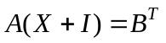, where 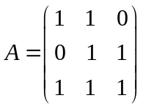 and 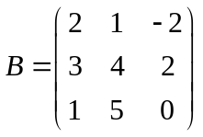.

2/ Solve the linear system 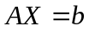, where 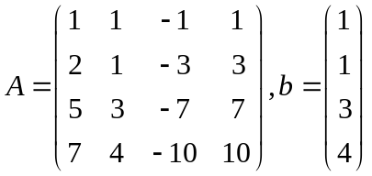.

3/ Let be a subspace of a vector
space 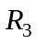. Find one basic and a dimension of the subspace .

4/ Given an inner product in as follow:
.
Find the distance between two vectors 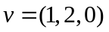 and 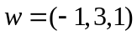.

5/ Let 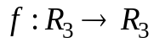 be a linear transformation.
Assume that .
a/ Compute 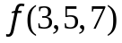.
b/ Find a dimension and one basic for Kerf.

6/ Diagonalize (if possible) the matrix 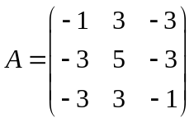,
( The characteristic equation of the matrix  is 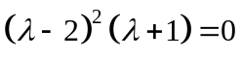)

7/ Make a change of variables that transforms the quadratic form
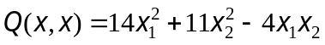 into the canonic form (using the orthogonal diagonalization method).

-----------------------  -----------------------

